**FOLDING INSTRUCTIONS FOR MY STORY TRACT**

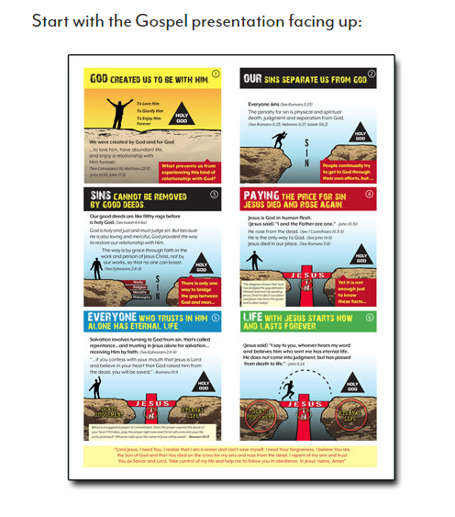**Step#1**

**Step#1**

**Step#**

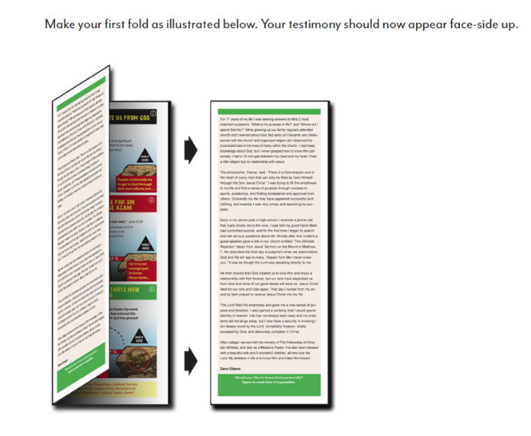**Step#2**

**Step#3**

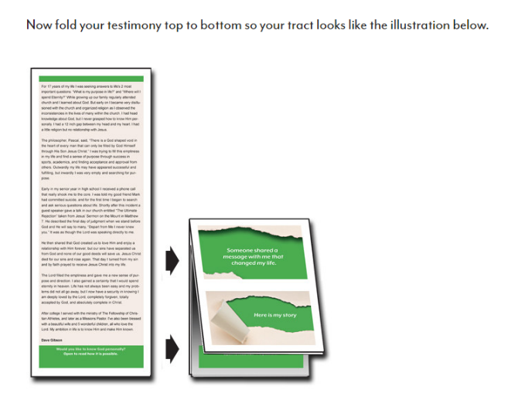

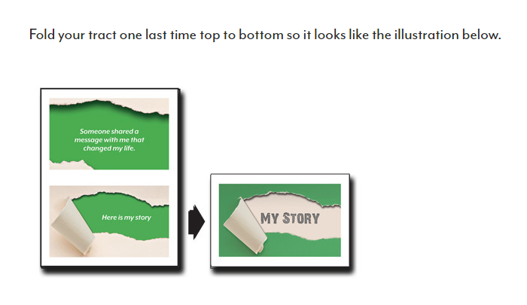**Step#4**